

**DCM Retention and Disposal Process**

**Copyright: Zain Mobile Telecommunications Company**

This is a confidential document prepared by Zain Mobile Telecommunications Company, for the Organizational usage. This document or any portion should not be available to any person other than concerned and authorized staff of Zain KSA. No part of this publication must be reproduced, stored in a retrieval system, transmitted in any form or by any means (electronic, mechanical, photocopying and recording or otherwise) without the permission of Zain KSA.

**Document Control Table:**

|  |  |
| --- | --- |
| **Item** | **Description** |
| **Process Name:** | DCM Retention and Disposal Process |
| **Sector/Department Name:** | Data Office |
| **Function Name:** | Data Governance Office |
| **Version Number:** | 1.0 |
| **Version Date:** | 21 Mar 2025 |
| **Process Owner:** | Data Governance Director |
| **Process Classification** |  |
| **Next Revision Date:** |  |

**Policy History:**

|  |  |  |  |
| --- | --- | --- | --- |
| **Version** | **Effective Date** | **Prepared by** | **Brief Explanation** |
| 1.0 |  | Data Governance Office |  |

**Reviewers List:**

|  |  |  |
| --- | --- | --- |
| **Name** | **Title & Department** | **Signature** |
| Ahmed Alamer | Director, Data Office |  |
|  | Director, Cyber Security |  |

**Approval List:**

|  |  |  |
| --- | --- | --- |
| **Name** | **Title & Department** | **Signature** |
| Salah Alghamdi | VP, Adjusted market |  |
|  | VP, Cyber Security |  |

**Key Abbreviations/Terminologies:**

|  |  |
| --- | --- |
| **Abbreviations/Terminology** | **Explanation** |
| Document | Documents are electronic or paper objects that contain instructions for tasks, requirements for how and when to perform a task or function, and logs of task execution and decisions. |
| Content | Content refers to the data and information inside the file, document, or website |
| DCM | Document and Content Management |

**Table of** **Contents**

1. Policy Details 6

1.1 Scope 6

1.2 Terminology 6

2. Document and Content Management Principles 6

3. Statements of Policy 7

4. Document Types 13

5. Exceptions and Approval: 15

6. Compliance & Enforcement: 15

# Process purpose

Document and content management is critical to the organization's overall data management strategy. The purpose of this process is to establish a standardized process for retaining, storing, and disposing of documents and content in compliance with Saudi Arabian regulations and business needs, while mitigating risks of data breaches or non-compliance.

## 1.1 Scope

This process applies to **all physical and electronic documents/content** created, received, or managed by Zain KSA, the following types of documents (but not limited to) are typically covered:

| **Category** | **Document Types** |
| --- | --- |
| **Policies and Procedures:** | Organizational Policies |
| Organizational Processes |
| Strategies, guidelines, and standards |
| **Internal Documents:** | Reports and memos |
| Meeting minutes and agendas |
| Presentations and training materials |
| Standard operating procedures (SOPs) |
| Work instructions and guidelines |
| **Contracts and Legal Documents:** | Contracts and agreements |
| Non-disclosure agreements (NDAs) |
| Intellectual property documents |
| Legal correspondence and filings |
| **Human Resources Documents:** | Employee records and personnel files |
| Job descriptions and employment contracts |
| Performance evaluations and appraisals |
| HR policies and handbooks |
| Training and development materials |
| **Financial Documents:** | Invoices and purchase orders |
| Financial statements and reports |
| Budgets and forecasts |
| Expense reports and receipts |
| Tax records and filings |
| **Marketing and Sales Documents:** | Marketing collateral (brochures, flyers, etc.) |
| Sales proposals and contracts |
| Advertising materials |
| Market research reports |
| Customer communication records |
| **Compliance and Regulatory Documents:** | Compliance policies and procedures |
| Regulatory filings and reports |
| Audit documentation |
| Certifications and licenses |
| Safety and environmental records |
| **Project Documents:** | Project plans and schedules |
| Project status reports |
| Requirements documents |
| Change management documentation |
| Risk assessments and mitigation plans |
| **Quality and Process Documents:** | Quality manuals and procedures |
| Process documentation and diagrams |
| Quality control records and reports |
| Corrective and preventive action (CAPA) documentation |
| **External Documents:** | Customer contracts and agreements |
| Supplier/vendor contracts and agreements |
| Industry publications and reports |
| Research papers and studies |

## This list is not exhaustive and may vary based on the specific needs and nature of the organization. Identifying and including the relevant documents critical for the organization's operations, compliance requirements, and knowledge management is essential.

# Roles and Responsibilities

In the scope of DCM Retention and Disposal Process, hereunder the related roles and responsibilities that will participate in the performing the activities related to the process.

* **Data Owner:** A senior stakeholder (department managers/managers) in a specific business area accountable for the quality, use, and meaning of that data in the Zain KSA, responsible for:
  1. Reviewing and Approving the Metadata provided from the business data steward for each document created, received, or managed by Zain KSA, at the line of business
  2. Approve retention/disposal schedules for each document / document category
  3. Authorize legal holds on certain documents
  4. Validate classifications for documents
* **Business Data Steward:** A Business Data Steward is the key representative in a specific business department who is responsible for the quality, use, and meaning of that data in the Zain KSA and will be responsible for:
  1. Define the Metadata for each document created, received, or managed by Zain KSA, at the line of business
  2. Define retention/disposal schedules for each document
  3. Define authorize legal holds for the documents
  4. Define classification for the documents
* **Document And Content Management (DCM) Officer:** DCM Officer is responsible for controlling the capture, storage, access, and use of data and information stored outside relational databases and will be responsible for:
  1. Oversee the lifecycle of documents and content from creation, storage, use, archiving, and eventual destruction, in compliance with organizational policies and regulations
  2. Enable and customize the classification and categorization capability for documents as per KSA requirements
  3. Enable legal holds feature on documents
  4. Implement the retention /disposal schedule for documents
  5. Implement retention/disposal workflows
  6. Maintain log for disposal actions for audit

# Process Functional Structure

Organizational chart displaying policy functional structure including the sectors and functions that have R&Rs under this policy.

## Record Keeping

|  |  |  |  |
| --- | --- | --- | --- |
| No. | Description of Record | Location | Period for Retention |
|  |  |  |  |
|  |  |  |  |
|  |  |  |  |

# DCM retention and disposal Process

Documents are a vital part of the effective functioning of any organization. Creating process for retention and disposal to control how long documents should be retained and when it can be safely disposed is vital for good information management, and to improve efficiency and mitigate legal and compliance risks.

The management of the retention and disposal is controlled using the metadata captured and maintained on document level, taking into consideration the legal hold that the legal advisor may apply on certain documents is the main condition that can exempt document from being disposed.

# 

# DCM Retention and Disposal processes

# Document and Content Management (DCM) Metadata Maintenance Process

The process flow graph below displays who is responsible for each step in the process, in which order it has to be executed, details the nature of each task, and defines a clear start and finish of the process.

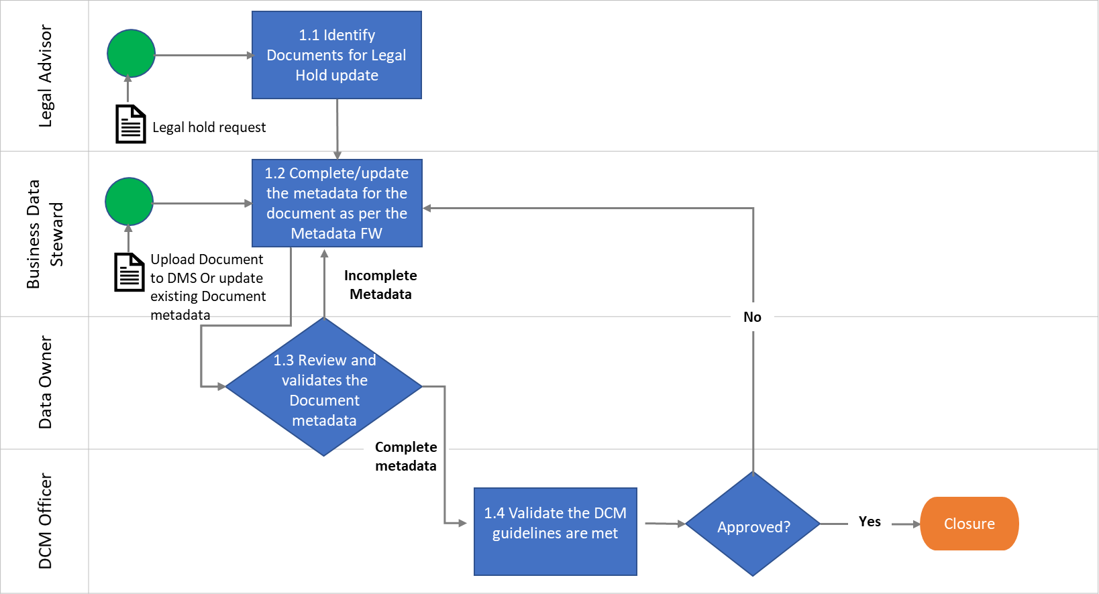

The table below provides additional details for each process step in the process flow. These steps are not in sequential order and are grouped by role.

|  |  |  |  |
| --- | --- | --- | --- |
| **Ref-ID** | **Process Step** | **Description** | **Owner** |
| DCM 1.1 | Identify Documents for Legal Hold update | This Step is one of the process triggers where the legal advisor initiates the process of adding/removing a legal hold based on a legal case status that requires maintaining certain documents as evidence. In this step, the legal advisor identifies the required document to be put on hold if the case is still open or to remove the legal hold from the documents if the case is closed. | Legal Advisor |
| DCM 1.2 | Complete/update the metadata for the document as per the Metadata FW | In this step, the Business Data Steward maintained the metadata related to newly uploaded documents or existing documents and keep it up-to-date. One of the inputs can come from the legal advisor to inform the Business Data Steward to add or remove legal hold from document. | Business Data Steward |
| DCM 1.3 | Review and validates the Document metadata | Data Owner reviews the metadata added/updated and approve or reject the information.  If approved, the workflow continues to Step DCM 1.4.  If rejected, the process returns to step DMC 1.3. | Data Owner |
| DCM 1.4 | Validate the DCM guidelines are met | The DCM Officer reviews the updated metadata for the documents and make sure it is aligned with the agreed upon guidelines for metadata update.  If approved, the workflow is complete and process closed  If rejected, the process returns to step DMC 1.2. | DCM Officer |

# Document and Content Management (DCM) Retention and Disposal Process

The process flow graph below displays who is responsible for each step in the process, in which order it has to be executed, details the nature of each task, and defines a clear start and finish of the process.

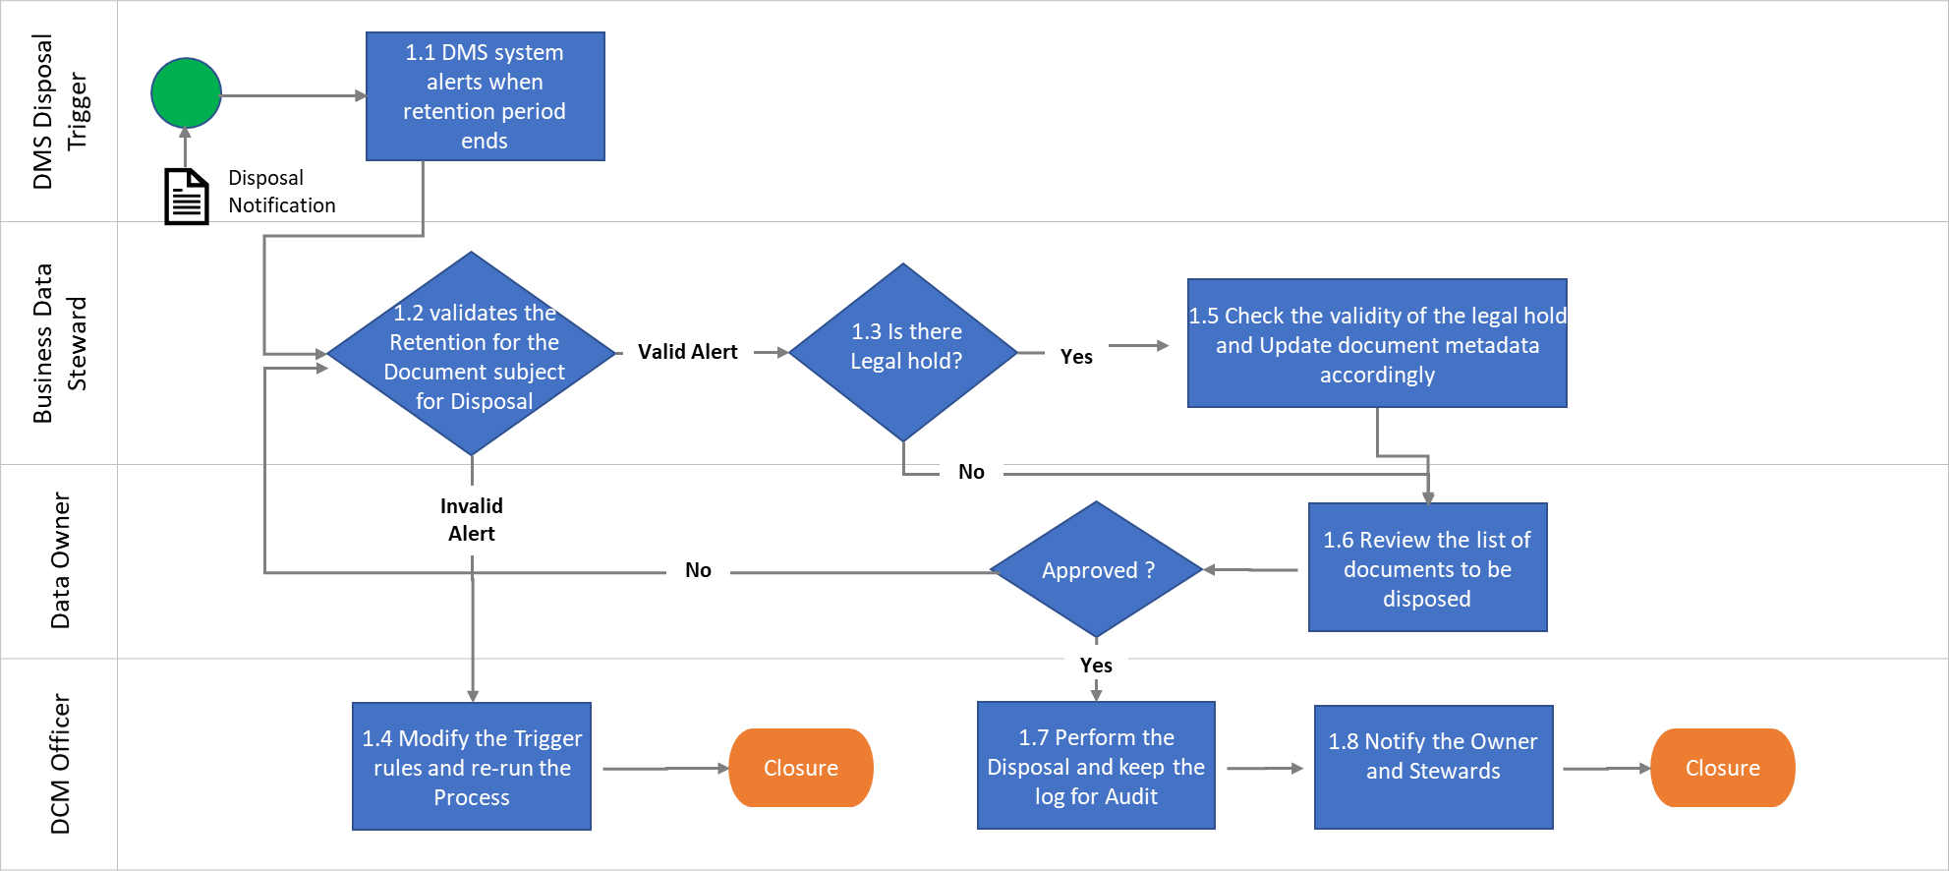

The table below provides additional details for each process step in the process flow. These steps are not in sequential order and are grouped by role.

|  |  |  |  |
| --- | --- | --- | --- |
| **Ref-ID** | **Process Step** | **Description** | **Owner** |
| DCM 1.1 | DMS system alerts when retention period ends | The DMS system generates triggers for the Business Data Stewards and notify them with the list of documents reached the retention period and ready to be disposed. This process to be scheduled on monthly basis. | DMS Disposal Trigger |
| DCM 1.2 | Validates the Retention for the Document subject for Disposal | In this step, the Business Data Steward review the list of documents subject for disposal and validate the retention period and make sure the documents are subject for disposal.  If the Documents are identified correctly, the process proceeds to step DCM 1.3  If the Documents are wrongly identified, the process proceeds to step DCM 14 | Business Data Steward |
| DCM 1.3 | Is there a Legal hold? | The Business Data Stewards validates if the documents are part of a requested legal hold, if Legal hold is applied then the process move to DCM 1.5, otherwise, the process move to DCM 1.6 | Business Data Steward |
| DCM 1.4 | Modify the Trigger rules and re-run the Process | The DCM Officer update the process and validate that it generates the right set of documents and then re-run the process | DCM Officer |
| DCM 1.5 | Check the validity of the legal hold and Update document metadata accordingly | The Business Data Steward checks if the legal hold assigned to the documents are still valid and update the document metadata accordingly. If the legal hold is valid, then the document should be exempted from the disposal. | Business Data Steward |
| DCM 1.6 | Review the list of documents to be disposed | The Data Owner reviews the final list, if the Data Owner approves the list, then process proceeds to step 1.7, otherwise, the process returns to step 1.2 | Data Owner |
| DCM 1.7 | Perform the Disposal and keep the log for Audit | The DCM Officer execute the disposal process for the identified documents following the cybersecurity guidelines and maintain the logs for the disposal actions for audit purpose. | DCM Officer |
| DCM 1.8 | Notify the Owner and Stewards | The DCM Officer notifies the Business Data Steward and Data Owner with the completion of the disposal process and share the log of the process with them as proof for disposal. | DCM Officer |

# RACI Matrix – Roles and Responsibilities

|  |  |  |
| --- | --- | --- |
| Field | Symbol | Definition |
| Responsible | R | The role is responsible for the execution of the respective scope or task | |
| Accountable | A | The role is accountable for taking the correct and thorough decision on the completion of a task. The role that is accountable must approve the work submitted by the responsible role. There must be only one accountable entity specified for each task or deliverable | |
| Consulted | C | The responsible and/or accountable role shall consult the to-be ‘consulted’ role for advice as required in the execution of the respective scope or task | |
| Informed | I | The responsible and/or accountable role shall inform the to be ‘informed’ role about the current progress achieved regarding the execution of the respective scope or task and/or its results. | |

|  |  |  |  |  |  |  |  |
| --- | --- | --- | --- | --- | --- | --- | --- |
| **Data Retention Domain** | **Chief Data Office** | | **Technology Working Group** | | **Business Working Group** | | **Support Function (Legal Advisor)** |
| **Data Governance Office** | **Data Architecture Office** | **Data Operation Steward** | **IT Data Steward** | **Business Data Steward** | **Data Owner** |
| 5.1 Document and Content Management (DCM) Metadata Maintenance Process | | | | | | | |
| DCM 1.1 - Identify Documents for Legal Hold update | R |  |  |  | R | R | AR |
| DCM 1.2 - Complete/update the metadata for the document as per the Metadata FW | R |  |  |  | R | R | I |
| DCM 1.3 - Review and validates the Document metadata | I |  |  |  | I | AR | I |
| DCM 1.4 - Validate the DCM guidelines are met | AR |  |  |  | I | I | I |
| Document and Content Management (DCM) Retention and Disposal Process | | | | | | | |
| DCM 1.1 - DMS system alerts when retention period ends | AR |  |  |  | I | I |  |
| DCM 1.2 - Validates the Retention for the Document subject for Disposal | I |  |  |  | R | A |  |
| DCM 1.3 - Is there a Legal hold? | I |  |  |  | R | A | C |
| DCM 1.4 - Modify the Trigger rules and re-run the Process | AR |  |  |  | I | I |  |
| DCM 1.5 - Check the validity of the legal hold and Update document metadata accordingly | I |  |  |  | R | A | I |
| DCM 1.6 - Review the list of documents to be disposed | I |  |  |  | I | A | I |
| DCM 1.7 - Perform the Disposal and keep the log for Audit | AR |  |  |  | I | I | I |
| DCM 1.8 - Notify the Owner and Stewards | AR |  |  |  | I | I | I |

# Compliance & Enforcement

The Data Governance Office is responsible for following the progress of this process and ensuring that others comply with the process steps and is responsible for enforcing the proper procedure. Along with the direct responsibility of the data governance office director, all relevant employees, and data compliance specialists from the data governance office team, in particular, are responsible for monitoring whether compliance has been observed and reporting any cases required so.

To achieve compliance and enforcement of this process, the following must be followed:

1. All employees shall follow the rules of this procedure and the related policy and all related standards to maximize its effectiveness.
2. All data users are responsible and accountable for reporting any non-compliance with this procedure and the related policies and in case of any problem, the data management and governance must be notified.
3. Data compliance specialists shall conduct periodic audits to identify and report any deficiencies in the implementation of this process and related policy

# Revision & Amendment

Any need for changes to the process is followed up by the data governance office and must be approved by the Data Management Steering Committee in ZAIN KSA or the Governor. This procedure shall be reviewed and evaluated for periodic updates.

# Appendix

All referenced documents referenced in the policy should be approved and appended

|  |  |
| --- | --- |
| Document Name | Remarks |
| Data Management Operating Model |  |
| Document and Content Management Policy |  |
|  |  |